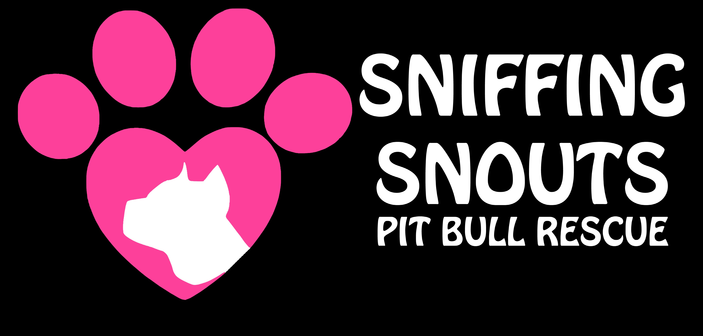
www.sniffingsnouts.com
ADOPTION CONTRACT
contact@sniffingsnouts.com

______________ , 20__

I, _______________, will take full responsibility of _______________. They will be an inside dog at all times and only go outside when supervised by an adult.
They will only be walked by an adult, or a teenager, that is training the dog (while supervised). They will be leashed, or kept in a fenced yard (while supervised), or in a house.
At no time will they be allowed to roam free.

Dogs name/age/sex/breed/color: __________________________________________

Adopters name: ________________________________________________________

Address: _________________________________________________________________

Phone #: ________________________________________________________________

Email: ___________________________________________________________________

Please initial next to following guidelines:

I will provide my dog with indoor shelter, water, food, exercise and medical needs,
on a regular basis.

I will have ID tags on my dog at all times.

I will take full responsibility for any financial needs my new dog may incur, regardless of
cost.

My dog will receive heart worm prevention monthly (Advantage Multi, Heartguard etc.).
Next Dosage due on:

My dog will receive flea and tick prevention monthly (Advantage, Frontline etc).
Next dosage due on:

I will register and pay the yearly fee for their microchip with: The American Kennel
Club/Companion Animal Recovery (http://www.akccar.org/).
The chip currently has Orange County Animal Services as the contact, so the dog can be returned directly to us, should they get lost.

I will provide Sniffing Snouts Pit Bull Rescue with my veterinarians name, address &
phone number. I have been given the dogs medical records & will give a copy to my vet.

Vet:

Address and phone #:

Before returning my dog for any reason, I will take them to training classes or consult a
dog trainer (we have some we can refer). I will also notify the rescue of any issues.

My dog will not be left unattended in a car, outside, or in a closed room.

Should any circumstance or emergency arise that prevents me from keeping
the dog, or if I do not adhere to this contract, I must return the dog to
Sniffing Snouts Pit Bull Rescue. This is non-negotiable. Under no
circumstances is the dog to be brought to an animal shelter, conveyed to
another animal rescue, or given to someone else without permission from
Sniffing Snouts Pit Bull Rescue. If an emergency arises, I understand that I
will not call Animal Services, but rather Sniffing Snouts Pit Bull Rescue, who
will then place the call to Animal Services, if necessary.

I will not take My dog to any shelter for disposal or adoption. I will not turn my dog
loose in the street for any reason whatsoever. Instead, I will contact Sniffing Snouts Pit
Bull Rescue, so that they may pick up the dog.

I will not barter, sell, or give my dog to another person. I will not allow my dog to
be used for fighting, or used in any kind of medical experimentation.

I will ensure that before moving, my dog is able to reside in the new residence. If
my dog is unable to reside in the residence, I will seek a different place, where
they will be allowed. I will not relinquish ownership of my dog due to moving and/or pet
policies.

Addendums (please initial):

____ My dog must not be left unattended with young children.

_____ My dog will not be left alone for more than six hours for the first two
weeks in his/her new home.

Home visits may occur in the next few weeks, if we feel they are needed.

I have been advised about Sniffing Snouts Pit Bull Rescues concerns
regarding dog parks and I have been given alternatives for socializing my
dog.

I understand that my new dog needs to be exercised on a regular basis
(walking, running, biking, or daycare) and that a fenced yard is not a form
of exercise. I am aware that failure to provide consistent and adequate
exercise may result in temperament changes in my dog.

I understand that my new dog needs to be regularly socialized with other
dogs, cats (unless there is known cat aggression), children
and adults. I am aware that failure to regularly socialize my dog may result in
temperament changes.
Please note that when doing introductions, do not allow face to face contact;
let each dog sniff the rear of the other dog. Normal introductions can resume
once both dogs are calm and there are no signs of aggression.

I understand that if I am a cigarette smoker, 2nd hand smoke can cause lung
cancer and various other tumors in my dog. I will not smoke around my dog.

A one time, non-refundable, adoption fee of $150.00 ($200 for puppies) will be given upon arrival of your new family member. We accept PayPal (contact@sniffingsnouts.com), cash, or checks (made to Sniffing Snouts Pit Bull Rescue).

Sniffing Snouts Pit Bull Rescue takes every precaution to assure the health of their dogs. I understand that no guarantee of any kind is given regarding the health of the pet I am adopting. I understand that after I sign this agreement, any vet bills incurred are solely my responsibility. I understand that I am required to take my new pet for a wellness visit with my vet within a month of adopting.

In the event that any one or more of the provisions contained herein shall, for any reason, be held to be invalid, illegal or unenforceable in any respect, such invalidity, illegality or unenforceability shall not affect any other provisions of this agreement, but this agreement shall be construed as if such invalid, illegal or unenforceable provisions had never been contained herein, unless the deletion of such provision or provisions would result in such a material change so as to cause completion of the transactions contemplated herein to be unreasonable.

______________________________
Adopting Party signature Date

______________________________
Sniffing Snouts Pit Bull Rescue Volunteer

