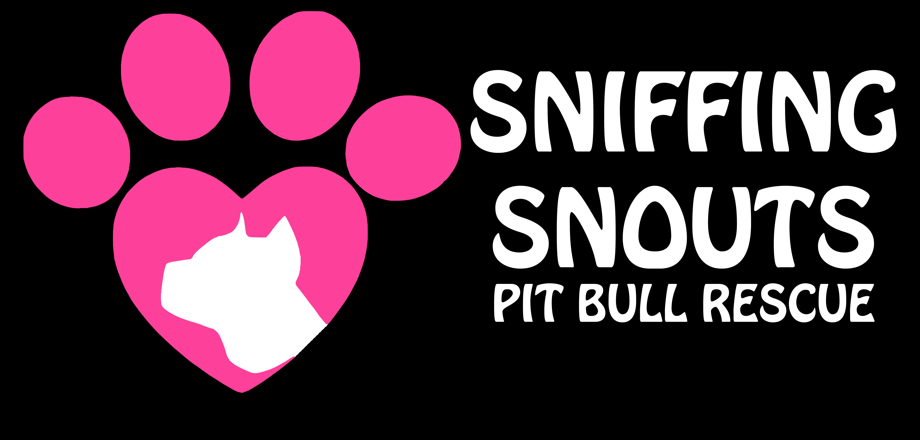
www.sniffingsnouts.com
LIABILITY WAIVER
Emergency Contact: Amy 321-331-6671/contact@sniffingsnouts.com
DOG'S NAME: _______________________________________________________________________
MALE/FEMALE AGE: _________ SPAYED/NUETERED
FOSTER PARENT(S)/Adopters:______________________________________________________

I agree that said dog will not be used for any illegal purposes and will never be fought in any way. If this clause is broken, I understand that law enforcement agencies will be notified and the dog will be confiscated.
Initials__________

I understand that Sniffing Snouts Pitbull Rescue may examine and make inquiries about said dog at any time. If not satisfied with the condition of the dog or the conditions in which it is kept, someone from the rescue will contact me to discuss. If an agreement cannot be met, I will agree to give the dog back to the rescue. Any veterinary services needed due to negligence or lack of care, will be my responsibility and payable to Sniffing Snouts Pitbull Rescue.
Initials__________

Release of Liability
I understand that Sniffing Snouts Pitbull Rescue cannot fully guarantee the health, behavior, age, or temperament of this dog. I hereby agree that there is no representation, warranty, or covenant of any kind from Sniffing Snouts Pitbull Rescue regarding the health, the training, the temperament, or the suitability of the dog.
I indemnify and hold harmless Sniffing Snouts Pitbull Rescue from any and all claims of liability for the dog’s actions; conduct, health, or behavior on or after the date of this form is signed. This Release of Liability and Indemnification shall apply to all known, unknown and unanticipated damages and/or injuries while the dog is in my possession. I hereby release and forever discharge Sniffing Snouts Pitbull Rescue from any and all causes of action, claims, or demands which I currently have or will have, hereinafter, against Sniffing Snouts Pitbull Rescue.
In the event that I/we should make any claim, demand, commence, or threaten to commence any action, claim, or proceeding against Sniffing Snouts Pitbull Rescue, this document may be raised as an estoppel and act as a complete bar for any recovery.
Initials__________
Venue
This Agreement shall be governed by the laws of the State of Florida. Venue shall be in Osceola County, Seminole County or Orange County, Florida.
Initials__________
Severability
In the event that any one or more of the provisions contained herein shall, for any reason, be held to be invalid, illegal or unenforceable in any respect, such invalidity, illegality or unenforceability, shall not affect any other provisions of this agreement, but this agreement shall be construed as if such invalid, illegal or unenforceable provisions had never been contained herein, unless the deletion of such provision or provisions would result in such a material change so as to cause completion of the transactions contemplated herein to be unreasonable.
Initials__________
I agree that I have read this document in full and understand that it contains a full and final release of any claim which I have or may have against Sniffing Snouts Pitbull Rescue.
Date____________________ Signature(s)_______________________
____________________ _______________________

