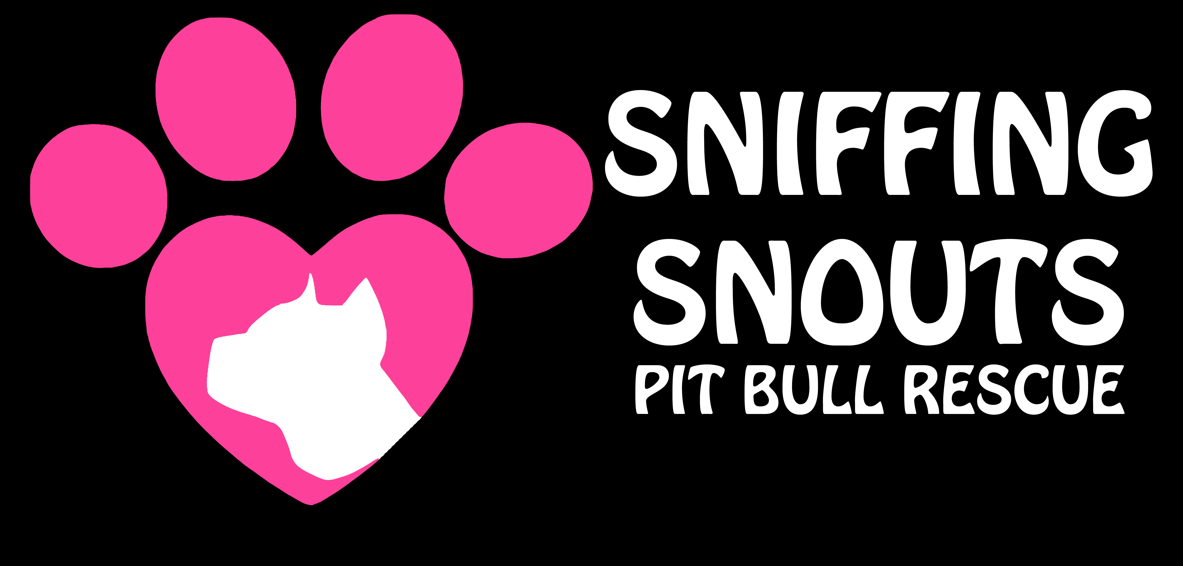
www.sniffingsnouts.com
FOSTER AGREEMENT
Emergency Contact:
Amy 321-331-6671/contact@sniffingsnouts.com

DOG'S NAME: ________________________________________________________________________

DESCRIPTION OF DOG: MALE/FEMALE AGE: ___________
SPAYED/NUETERED
COLOR/MARKINGS: ________________________________________________

SHOTS DATE: _________ RABIES DATE: _________ MICRO-CHIP/RABIES TAG#: ______________

NAME/ADDRESS, PHONE# OF VET & FACILITY: ________________________________________________________________________________________________

________________________________________________________________________________________________

FOSTER PARENT(S): ________________________________________________________________________

FOSTER PARENT(S) ADDRESS: ____________________________________________________________

CITY: _________________________ STATE: _________ ZIP: ____________

HOME PHONE: ( )__________ CELL: ( )____________ ALT#: ( )________________

EMAIL ADDRESS: ____________________________________________________

DATE PLACED IN FOSTER HOME: ______________

I AGREE THAT SNIFFING SNOUTS PITBULL RESCUE MAY AT ANY TIME CONTACT ME TO
VISIT THE PREMISES WHERE THE FOSTER PET IS BEING KEPT TO CHECK ON ITS WELL
BEING.

I AGREE THAT SNIFFING SNOUTS PITBULL RESCUE MAY, AT ANYTIME, RECLAIM THIS PET
IF NOT SATISFIED WITH ITS CARE.

I AGREE TO FEED, PROPERLY CARE FOR, AND TREAT THIS ANIMAL WITH KINDNESS AND
RESPECT.

IF FOR ANY REASON, IF I CANNOT COMPLY WITH THIS FOSTER AGREEMENT OR
IF THE FOSTER IS NOT SATISFACTORY, I WILL CONTACT THE RESCUE IMMEDIATELY.

I AGREE THAT IF I CANNOT KEEP THIS PET FOR ANY REASON WHATSOEVER, I MUST
CONTACT SNIFFING SNOUTS PITBULL RESCUE FOR THE PET TO BE RETURNED TO THEM
IMMEDIATELY.

I AGREE THAT I WILL NOT TAKE THIS PET TO ANY SHELTER FOR DISPOSAL OR ADOPTION
OR TURN IT LOOSE IN THE STREET. I WILL NOT BARTER, SELL OR GIVE THIS PET TO
ANOTHER PERSON. I WILL NOT ALLOW IT TO BE USED FOR MEDICAL OR
ANY OTHER EXPERIMENTATION OR RITUAL.

I understand and acknowledge that I do not have any right or authority to keep or place the foster dog in other homes or with other individuals.

I agree to provide this dog and all other animals that I own with proper veterinary care as is recommended. This includes a monthly heartworm prevention and flea control program.

I agree to keep this dog clean and groomed at all times.

I AGREE to feed a wholesome, premium dog food and have fresh water available at all times. This food will be provided by the rescue.

I agree that this dog will reside in the home and not outside.

I agree that this dog will BE CRATED WHEN I AM NOT HOME – NO EXCEPTIONS.

I agree that this dog will never be allowed off a leash when it is outdoors, unless it is supervised in a fenced in area or fenced yard.

I agree to return this dog to a member of SNIFFING SNOUTS PITBULL Rescue within 24 hours of being asked to return IT. If i am unavailable at the time the dog is needed, i agree to make the dog available for pick up within the 24-hour period.

i will not employ harsh training methods. i will never strike or choke the dog in an attempt to discipline.

AS WITH FOSTERING ANY ANIMAL, COMES WITH POTENTIAL RISKS. ANIMALS CAN AT
TIMES BE UNPREDICTABLE ESPECIALLY WHEN PLACED IN NEW AND UNFAMILIAR
CIRCUMSTANCES. THE FOSTER UNDERSTANDS THIS AND AGREES TO THE FULLEST EXTENT
PERMITTED BY LAW TO:

- ABIDE BY ALL HOA RULES IF APPLICABLE
- ABIDE BY ALL COUNTY, STATE, CITY LAWS THAT PRETAIN TO ANIMALS
The foster understands that their foster dog needs to be regularly socialized with other dogs,
cats (unless there is known cat aggression – then training is needed), children
and people. Failure to regularly socialize my dog may result in temperament changes.
Please note that when doing introductions, do not allow face to face contact, let each dog sniff the rear of the other dog. Normal introductions can resume once both dogs are calm and there are no signs of aggression.

I understand that if I am a cigarette smoker, 2nd hand smoke can cause lung cancer and various other tumors in my foster dog. I will not smoke around my foster dog.

The foster understands this and agrees to the fullest extent permitted by law, to indemnify and hold harmless Sniffing Snouts Pitbull Rescue from any and all claims, damages, loss and expenses including but not limited to attorney's fees, costs arising out of any accident, injury or other occurrence resulting from the fostering of the dog(s) by the foster(s) or foster(s) family and pets.

Sniffing Snouts Pitbull Rescue will provide medical coverage for the above named dog, however, if the dog is injured, killed by direct result of the negligence of the foster he/she is responsible for that vet bill at the discounted (if applicable) price of Sniffing Snouts Pitbull Rescue.

I understand that if at anytime there is an issue with the dog, I will immediately contact Sniffing Snouts Pitbull Rescue to discuss the issues at hand. Any non approved vet visits resulting charges will not be paid by the rescue without proper documentation that it is a dire emergency and a reasonable attempt was made to contact the rescue.

In the event of emergency, please contact Amy Mills at 321-331-6671. You can also
email contact@sniffingsnouts.com

In the event that any one or more of the provisions contained herein shall, for any reason, be held to be invalid, illegal or unenforceable in any respect, such invalidity, illegality or unenforceability shall not affect any other provisions of this agreement, but this agreement shall be construed as if such invalid, illegal or unenforceable provisions had never been contained herein, unless the deletion of such provision or provisions would result in such a material change so as to cause completion of the transactions contemplated herein to be unreasonable.

This Agreement shall be governed by the laws of the State of Florida.

By signing this agreement below, the foster affirms that they have read, understand, and agree to all provisions in this agreement and the responsibility of a foster dog. This writing contains the entire agreement and no representations other than those contained in the writing have been made by Sniffing Snouts Pitbull Rescue.

I have read and agree to all terms and conditions of this agreement & agree to provide proof of identity.
_________________________________________ ________________________
Printed name Date

__________________________________________ __________________________________________
Signature Witness/Date

