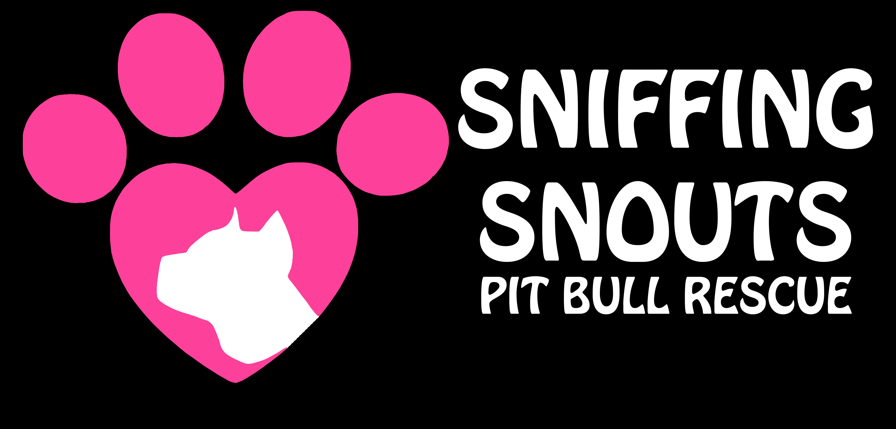 www.sniffingsnouts.com
ADOPTION CONTRACT
Emergency Contact:
Amy 321-331-6671/contact@sniffingsnouts.com

______________ , 2013

I, _______________, will take full responsibility of _______________. They will be an inside dog at all times and only go outside when supervised by an adult.
They will only be walked by an adult or a teenager that is training the dog (while supervised). They will be leashed or kept in a fenced yard (while supervised) or in a house.
At no time will they be allowed to roam free.

Animal’s name/age/sex/breed/color: __________________________________________

Adopter’s Full name: ________________________________________________________

Address: _________________________________________________________________

Phone #: ________________________________________________________________

Email: ___________________________________________________________________

Facebook: ____________________________________________________________________

Please list any additional people in the home, including their age: _________________________________________________________________________

Please list current pets in the home, including their breed/age: _________________________________________________________________________

Are your pets spayed/neutered? ____________ Are all pets up to date on vaccines? ________

What type of residence do you live in? _______ is it fenced? ______ Do you rent or own? ____

Do you have any weight or breed restrictions that would prevent you from adopting? ________
Please initial next to following guidelines:

I will provide my dog with indoor shelter, water, food, exercise and medical needs
on a regular basis.

I will have ID tags on my dog at all times.

I will take full responsibility for any financial needs my new dog may incur, no matter
the cost.

My dog will receive heartworm prevention monthly (Advantage Multi, Heartguard etc.).
Next Dosage due on:

My dog will receive flea and tick prevention monthly (Advantage, Frontline etc).
Next dosage due on:

I will register and pay the yearly fee for their microchip with
The American Kennel Club/Companion Animal Recovery (http://www.akccar.org/). The
chip currently has Orange County Animal Services as the contact, so the dog can be
returned directly to us, should they get lost.

I will provide Sniffing Snouts Pitbull Rescue with my veterinarian’s name, address &
phone number. I have been given the dogs medical records & will give a copy to my vet.

Vet:__________________ Address and phone: __________________________

Before returning my dog for any reason, I will take them to training classes or consult a
dog trainer (we have some we can refer).

My dog will not be left unattended in a car or left in a room by itself with the door closed.
If they need to be separated in a room for whatever reason, I will use a baby gate or a
crate.

Should any circumstance or emergency arise that prevents me from keeping the dog, or
if I do not adhere to this contract, I must return the dog to Sniffing Snouts Pitbull
Rescue.
This is non-negotiable. Under no circumstances is the dog to be brought to an animal
shelter, conveyed to another animal rescue, or given to someone else without permission
from Sniffing Snouts Pitbull Rescue. If an emergency arises, I understand that I will not
call Animal Services, but rather Sniffing Snouts Pitbull Rescue who will then place the call
to Animal Services, if necessary.

I will not take my dog to any shelter for disposal or adoption. I will not turn it loose in
the street for any reason whatsoever. Instead, I will contact Sniffing Snouts Pitbull
Rescue so that they may pick up the dog.

I will not barter, sell or give my dog to another person. I will not allow my dog to
be used for fighting or used in any kind of medical experimentation.

I will ensure that before moving, my dog is able to reside in the new residence. If
my dog is unable to reside in the residence, I will find a new different place where
they will be allowed.
I will not relinquish ownership of my dog due to moving and/or pet policies.

Addendums (please initial):

____ My dog must not be left unattended with young children.

_____ My dog will not be left alone for more than six hours for the first two
weeks in his/her new home.

Home visits may occur in the next few weeks if we feel they are needed.

I have been advised about Sniffing Snouts Pitbull Rescues concerns
regarding dog parks and I have been given alternatives for socializing my
dog.

I understand that my new dog needs to be exercised on a regular basis
(walking, running, biking or daycare) and that a fenced yard is not a form
of exercise. I am aware that failure to provide consistent and adequate
exercise may result in temperament changes in my dog.

I understand that my new dog needs to be regularly socialized with other dogs,
cats (unless there is known cat aggression – then training is needed), children
and people. I am aware that failure to regularly socialize my dog may result in
temperament changes.
Please note that when doing introductions, do not allow face to face contact,
let each dog sniff the rear of the other dog. Normal introductions can resume
once both dogs are calm and there are no signs of aggression.

I understand that if I am a cigarette smoker, 2nd hand smoke can cause lung
cancer and various other tumors in my dog.

A one time adoption fee/donation (non-refundable) of $150.00 ($200 for puppies) will be given upon arrival of your new family member. Cash or check made to Amy Mills. We also accept Paypal: contact@sniffingsnouts.com

Sniffing Snouts Pitbull Rescue takes every precaution to assure the health of their dogs. I understand that no guarantee of any kind is given regarding the health of the pet I am adopting. I understand that after I sign this agreement, any vet bills incurred are solely my responsibility. I understand that I am required to take my new pet for a wellness visit with my vet within a month of adopting.

In the event that any one or more of the provisions contained herein shall, for any reason, be held to be invalid, illegal or unenforceable in any respect, such invalidity, illegality or unenforceability shall not affect any other provisions of this agreement, but this agreement shall be construed as if such invalid, illegal or unenforceable provisions had never been contained herein, unless the deletion of such provision or provisions would result in such a material change so as to cause completion of the transactions contemplated herein to be unreasonable.

______________________________
Adopting Party signature Date

______________________________
Sniffing Snouts Pitbull Rescue Volunteer

